**Task # 01:** Get Order id, Product id, Unit price from Order Details.

**Query:** select OrderID, ProductId, UnitPrice from [Order Details]

**Result:**

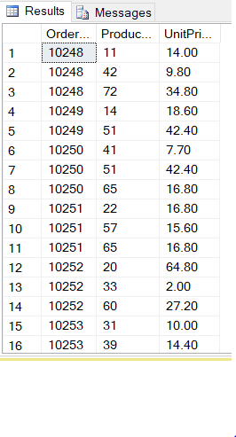

**Task # 02:** Find Title of employee Nancy.

**Query:** select FirstName, LastName, Title from Employees where FirstName = 'nancy'

**Result:**



**Task # 3:** Get the price of an order (by multiplying unit price by quantity).

**Query:** select unitprice * quantity from [Order Details]

**Result:**

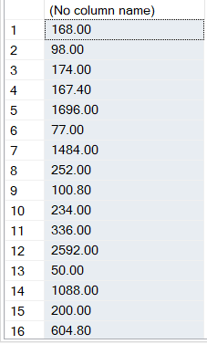

**Task # 4:** Display all cities that employees belong to but don’t allow repetition.

**Query:** select distinct city from Employees

**Result:**

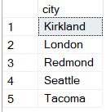

**Task # 5:** Find complete name of all employees.

**Query:** select firstname , lastname from Employees

**Result:**

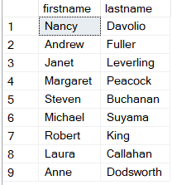

**Task # 6:** Display data of all employees those working as Sales Representative.

**Query:** select * from Employees where title = 'sales representative'

**Result:**

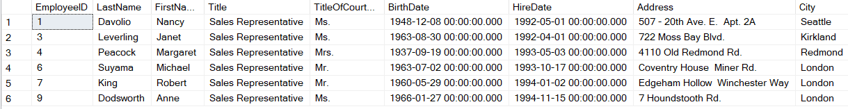

**Task # 7:** Display complete name of employees those lives in London.

**Query:** select firstname, lastname , city from Employees where city = 'london'

**Result:**

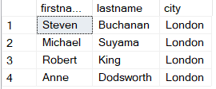

**Task # 8:** Display product name whose unit price are greater than 90$.

**Query:** select productname , unitprice from Products where UnitPrice > '$90'

**Result:**

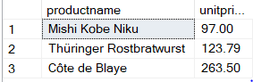

**Task # 9:** List the name of all employees whose first name starts with the letter ‘A’.

**Query:** select firstname from Employees where firstname like 'A%'

**Result:**

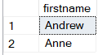

**Task # 10:** In Customer table, display all cities that ends with the letter ‘a’.

**Query:** select City from Customers where city like '%a'

**Result:**

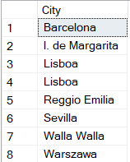

**Task # 11:** Display names of all employees whose name contain ‘an’.

**Query:** select firstname from Employees where firstname like '%an%'

**Result:**

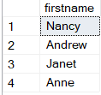

**Task # 12:** Display all the orders where unit price lies in the range of 10$ to 40$.

**Query:** select UnitPrice from [Order Details] where UnitPrice between '$10' AND '$40'

**Result:**

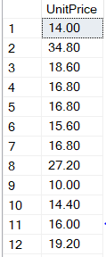

**Task # 13:** Display the company name where Region is NULL in Customer Table.

**Query:** select companyname , region from Customers where region is null

**Result:**

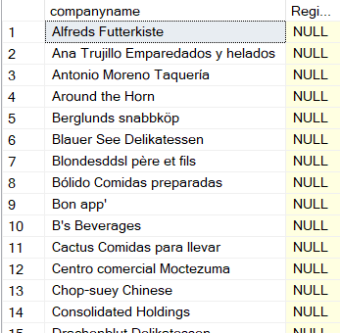

**Task # 14:** Write a query to list employees who live in London, Seattle or Redmond

**Query:** select * from Employees where city in ('London','Seattle','Redmond')

**Result:**

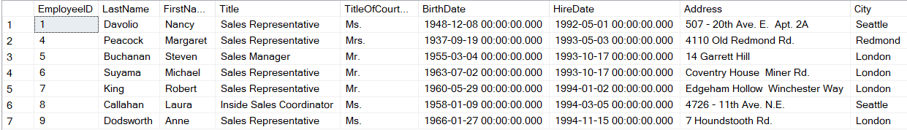

**Task # 15:** Write a query to list employees whose address contains numbers in its start.

**Query:** select firstname , lastname, [Address] from Employees where [Address] like '%[1-9]%'

**Result:**

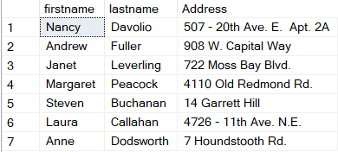

**Task # 16:** Write a query to list employees whose address does not contain Rd.

**Query:** select firstname, lastname, [Address] from Employees where [Address] not like '%Rd%'

**Result:**

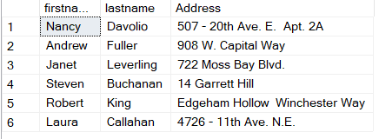

**Task # 17:** Write a query to list all those employees whose TitleofCourtesydoes not starts with M.

**Query:** select firstname, lastname ,TitleOfCourtesy from Employees where TitleOfCourtesy not LIKE'M%';

**Result:**



**Task # 18:** List order details whose ShipRegion is not Null.

**Query:** select OrderID, ShipRegion from Orders where ShipRegion is not null

**Result:**

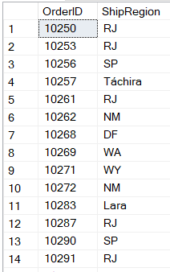

**Task # 19:** List all products where UnitPrice is between 10 and 15 and QuantityPerUnit contains “bottles”

**Query:** select unitprice, quantityperunit from Products where UnitPrice between '10' AND '15'

AND QuantityPerUnit like '%bottles%'

**Result:**

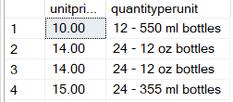

**Task # 20:** List all products where UnitPrice is not in 10,12,15,17 or 19

**Query:** select UnitPrice from Products where UnitPrice not in ('10','12','15','17', '19')

**Result:**

